Forecasting Tool
By Duc Duy Nguyen

Functional Requirements Document
April 2010


Version | Description of Change | Author | Date
1 | Creation | Duc Duy Nguyen | April 19th 2010
1.1 | Revised | Duc Duy Nguyen/Ann Shea | May 21th 2010

CONTENTS
1 INTRODUCTION 4
1.1 Purpose 4
1.2 Scope 4
1.3 Background 4
1.4 References 4
1.5 Assumptions and Constraints 4
1.6 Document Overview 4
2 METHODOLOGY 5
3 FUNCTIONAL REQUIREMENTS 5
4.1 Context 5
4.2 User Requirements 5
4.3 Data Flow Diagrams 7
4.4 Logical Data Model/Data Dictionary 9
4.5 Functional Requirements 9
5 OTHER REQUIREMENTS 10
5.1 Interface Requirements 10
5.2 Data Conversion Requirements 10
5.3 Hardware/Software Requirements 10
5.4 Operational Requirements 10
APPENDIX A - GLOSSARY 14

INTRODUCTION

Purpose

This system will be created to facilitate and automate the forecasting process for the entire sales force. It also includes a company wide funnel management tool that will show how future opportunities affect budget. This document describes what should and should not be the possible to do with the forecasting tool.

Scope
This document describes the requirements that should be met by the forecasting tool. It also describes the connection to other programs that this tool will have to maintain.

Background
Since reports with goals already exists, this program will try to automate the data entry process. The reports will then be automatically updated to reflect the data.

References
This document reflects what was discussed with Dean Whitelaw, Ann Shea and Steve Dustin in a meeting on April 19th 2010.

Assumptions and Constraints

Assumptions
- Forecasting will be mainly done once at the beginning of the year and refreshed every quarter.
- Customer segments are determined by the Ship-To Territory Code.
- Product categories are determined by the FRA1REL4 table that corresponds to the product code categories in Nomis.

Constraints
- This program should be ready and operational for FY2011 (October 1st 2010).
- Since the forecasting process should start sooner, there should be a soft deadline for August 1st.
- Unless asked, the cubes are refreshed once a day and it is not meant to be a real time program, so any changes will only reflect on the reports of the next day.

Document Overview
[Provide a description of the document organization.]

METHODOLOGY
Involved in the planning of this project is the IT department and the Sales team. Throughout weekly meeting, the complete requirements are to be compiled and documented.

FUNCTIONAL REQUIREMENTS

Context
The program will have 4 types of users. Each of these has their own interface and can view their respective corresponding data.
Exhibit 1 – High level view of the forecasting tool
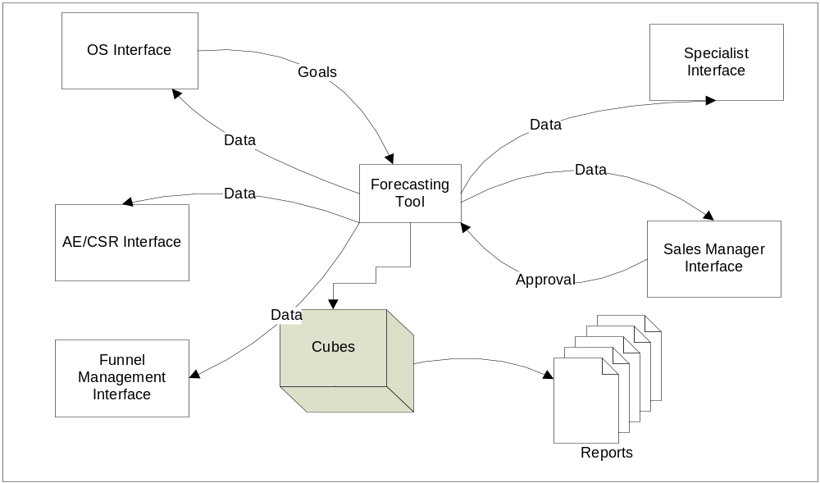

User Requirements

User requirements are divided by types of users. The type of user one person will be determined by Active Directory and no login is necessary on the system. The user will have to be on a computer on the LCL Domain, or connected through VPN. In the event that a person belongs to two roles, they will have access to both interfaces.

Outside Salesmen (OS)

Outsides salesmen should be able to view/change the following items:

- Goals by product category (Bookings)
- Goals by segments (Bookings)
- Goals for specific customers in the SA or CB segments (Bookings)
- Progress reports
- Funnel Management

They are also restricted to their own goals and they don’t see other OS’ goals. They should see numbers from past fiscal years to help them set their goals.

Inside Salesmen (AE/CSR)

Inside Salesmen should be able to view (and only view) the following items (where applicable):

- Goals by product category (Bookings)
- Margin Goals by product category (Sales)
- Goals by segments (Bookings)
- Progress Reports

Specialists

Specialists can see what salesmen are forecasted against their respective product category as well as the whole picture for information purposes

- Make changes or recommend changes to other users.
- Progress reports
- Product category centric view
- Global View

Sales Manager (AE/OS Manager)

Here are the required functionalities for the Sales managers:

- Approve Goals
- View everybody’s goals individually
- Change goals
- Suggest changes
- Global view
- Progress reports
- Funnel Management
- Set margin Goals

Data Flow Diagrams

This dataflow diagram shows which database are used and what are the relations between them:

Exhibit 1 – High level view of the forecasting tool

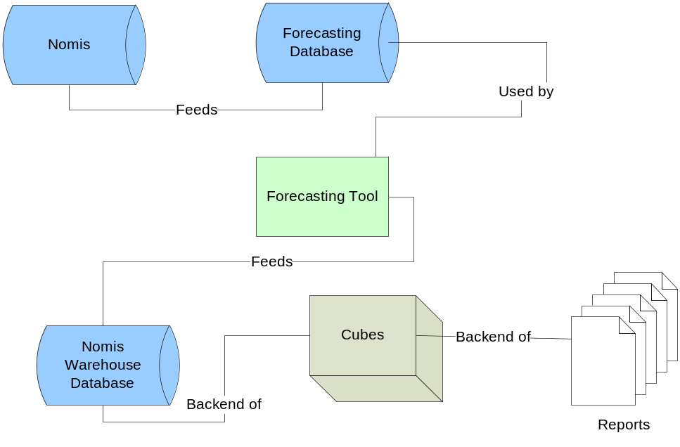

Outside Salesmen (OS)/Inside Salesmen (AE/CSR)

This is the proposed data flow for OS. The approval process is to make the sales manager aware of changes to a Salesman’s forecast or to make both parties agree on a revised forecast.
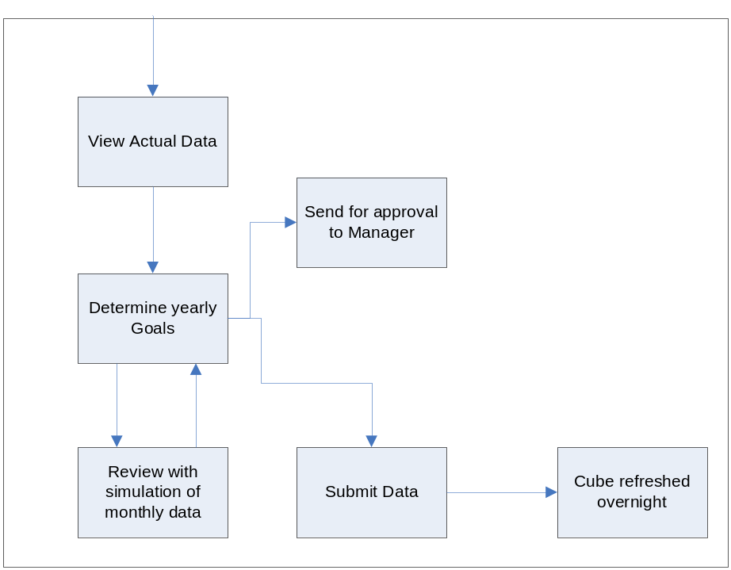

Specialists

This is a proposed data flow for specialists. Note that a specialist changing salesman’s forecast will happen very rarely (if at all). 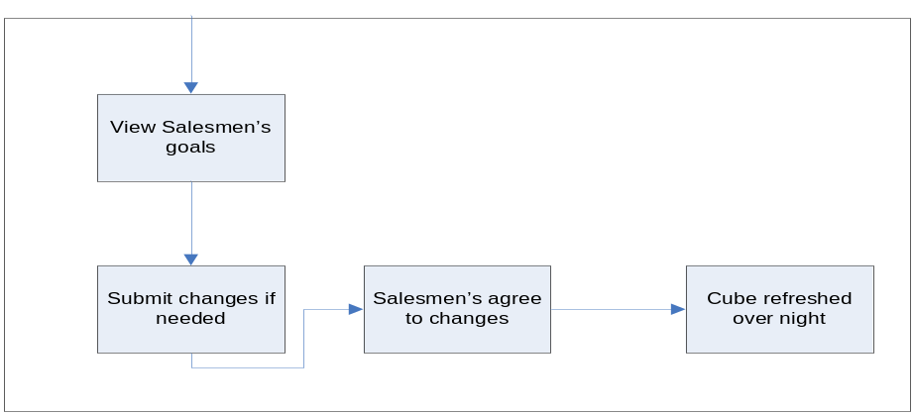

Sales Manager (AE/OS Manager)
This is a proposed data flow for Sales Managers. Note that a Sales manager changing salesman’s forecast will happen very rarely (if at all).
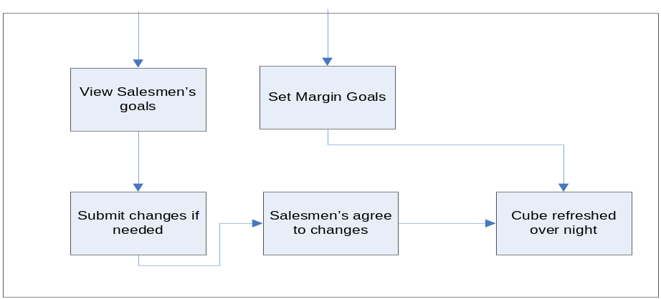

Logical Data Model/Data Dictionary

This program will need to use retrieve data from the cubes (Microsoft Analysis Services) and write into SQL Server tables.

Logical data model to come.

Functional Requirements

Functional Requirements Group 1
[List the functional requirements for each functional requirements group.]
Exhibit 4 - Sample Requirements Group 1
Section/ Requirement ID | Requirement Definition
FR1.0. | The system shall [parent requirement group 1].
FR1.1 | The system shall [child/parent requirement].
FR1.1.1 | The system shall [child requirement].
FR1.1.2 | The system shall [child requirement].

Functional Requirements Group 2, Etc.

OTHER REQUIREMENTS

Interface Requirements

The interface should be easy to use. It will be in the form of a website, and accessible with a browser.

Hardware Interfaces
N/A

Software Interfaces

This tool will interface with the following applications:

Application Name | Owner | Interface details
Exchange / AD | Khac-Uy | The forecast tool will interface with Exchange and AD to determine the role of the user and orient him towards the appropriate interface.
SQL Server | Duc Duy Nguyen | The forecast tool will interface with SQL Server as database backend.
IIS | Khac-Uy Ly | The forecast tool will be hosted on a IIS web server.
Reporting Services | Duc Duy Nguyen | Frontend server for reports, and distribution of reports.
Analysis Services | Duc Duy Nguyen | The forecast tool will update the data in the backend of cubes.

Communications Interfaces
N/A

Data Conversion Requirements
N/A

Hardware/Software Requirements
This will run on the LCL-SQL2k5-S with a SQL Server 2005. The front end will be a ASP .NET web site written in VB .NET or C# .NET. The required servers must be up so

Operational Requirements
[Provide the operational requirements in this section.
Do not state how these requirements will be satisfied. For example, in the Reliability section, answer the question, “How reliable must the system be”? Do not state what steps will be taken to provide reliability.
Distinguish preferences from requirements. Requirements are based on business needs, preferences are not. If, for example, the user requires a special response but does not have a business-related reason for it, that requirement is a preference.
Other applicable requirements on system attributes may be added to the list of subsections below.]
Operational requirements describe how the system will run and communicate with operations personnel.

Security and Privacy
Here is a list of the security requirements:
The Consequences of the following breaches of security in the subject application are as follows:
- Loss or corruption of data
The system will be backed up every night through SQL Server backups and standard IT backup procedures.
- Disclosure of secrets or sensitive information
Since the forecasting and funnel divulges most of the sales strategy of the company, it should be fairly protected. Here are the following steps that should guard sensitive information from getting out.
- This program does not reside on the internet and is strictly an intranet program. Therefore outsides users can not access this program because the company firewall will block them.
- The entire funnel will not be shown to anybody except upper management and sales managers.
- In general, users can only see data relating to them.

- Disclosure of privileged/privacy information about individuals
No personal information should reside in this database
- Corruption of software or introduction of malware, such as viruses
N/A
- State the type(s) of security required. Include the need for the following as appropriate:
- Access by user role or types.
Access to the program is controlled by Active Directory and transparent to the user.
- State access control requirements by data attribute. For example, one group of users has permission to view an attribute but not update it while another group of users has permissions to update or view it.
- State access requirements based on system function. For example, if there is a need to grant access to certain system functions to one group of users, but not to another. For example, "The system shall make Function X available to the System Administrator only".
- State if there is a need for certification and accreditation of the security measures adopted for this application]
The Security Section describes the need to control access to the data. This includes controlling who may view and alter application data.

Audit Trail
[List the activities recorded in the application’s audit trail. For each activity, list the data recorded.]

Reliability
A. [State the following in this section:
- State the damage can result from failure of this system—indicate the criticality of the software, such as:
- Loss of human life
- Complete or partial loss of the ability to perform a mission-critical function
- Loss of revenue
- Loss of employee productivity
- What is the minimum acceptable level of reliability?
B. State required reliability:
- Mean-Time-Between-Failure is the number of time units the system is operable before the first failure occurs.
- Mean-Time-To-Failure is the number of time units before the system is operable divided by the number of failures during the time period.
- Mean-Time-To-Repair is the number of time units required to perform system repair divided by the number of repairs during the time period.]
Reliability is the probability that the system processes work correctly and completely without being aborted.

Recoverability
A. In the event the application is unavailable to users (down) because of a system failure, the application should be brought up in the fastest way possible, but in no way is this application critical to the production of the company.
B. The database must be capable of being restored to its condition in the fastest way possible but it is not a critical application.

System Availability
The application must be available to users Monday through Friday between the hours of 6:30 a.m. and 5:30 p.m. EST.

General Performance
A. Response time for queries and updates
There should be no lag for queries and updates.
B. Throughput
Fast.
C. Expected rate of user activity
Low , once per quarter for forecasting or to update the funnel (1-2 per week).

Capacity
[List the required capacities and expected volumes of data in business terms. Do not state capacities in terms of system memory requirements or disk space—if growth trends or projections are available, provide them]

Data Retention
Data should be retained for the longest possible for analysis purposes.

Error Handling

Error should be logged and fixed as soon as possible.

Validation Rules
[Describe System Validation Rules.]

Conventions/Standards
[Describe system conventions and standards followed.
For example: Microsoft standards are followed for windows, Institute of Electrical and Electronics Engineers (IEEE) for data formats, etc.]

APPENDIX A - GLOSSARY
[Define terms, acronyms, and abbreviations used in the FRD.]

